helm repo add stable https://charts.helm.sh/stable

helm repo update

helm install prometheus stable/prometheus-operator

//Change Type to LoadBalancer for external Access

kubectl edit svc prometheus-prometheus-oper-prometheus

//Make sure to enable the Port in Master Node 9090

//now we will get an external IP

http://a9aa0dbbdddb14ff69ef47e5ab69f2f5-199503218.us-east-1.elb.amazonaws.com:9090/

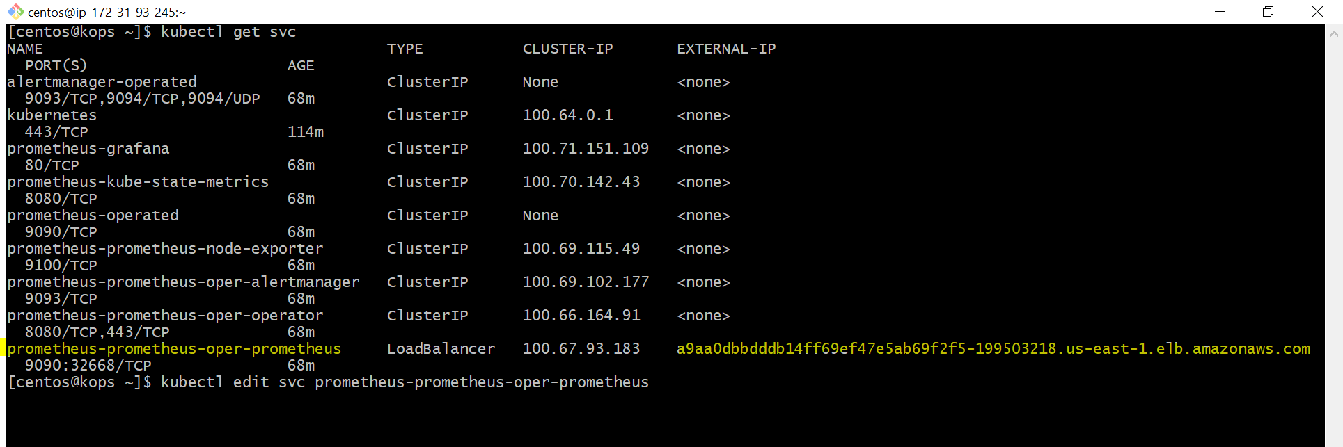

Grafana Same we should edit the SVC of Grafana and change the Type to Load Balancer

//To get the password and username of Grafana

kubectl get secret prometheus-grafana -o yaml

Example Dashboards

<https://www.fosstechnix.com/kubernetes-cluster-monitoring-with-prometheus-and-grafana/>